**Screenshots**

Invalid Username and password. Click Login Button

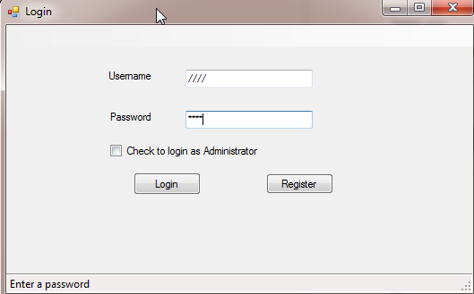

Both username and password text boxes are cleared. Labeled is displayed in red for “Invalid Username and Password”

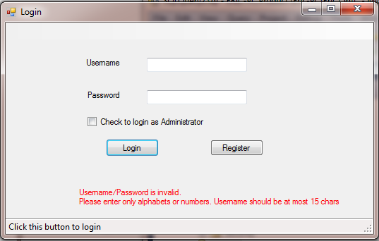

Valid user.

Username: **new**

Password: **user**

Click **Login** with Valid Username and password

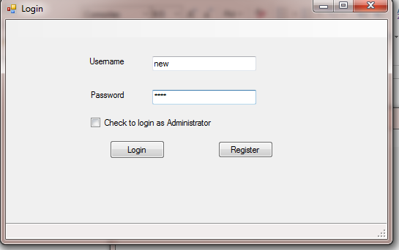

Current Product List is displayed. Can place order depending qty entered in textbox. Example: Order for 10 chairs

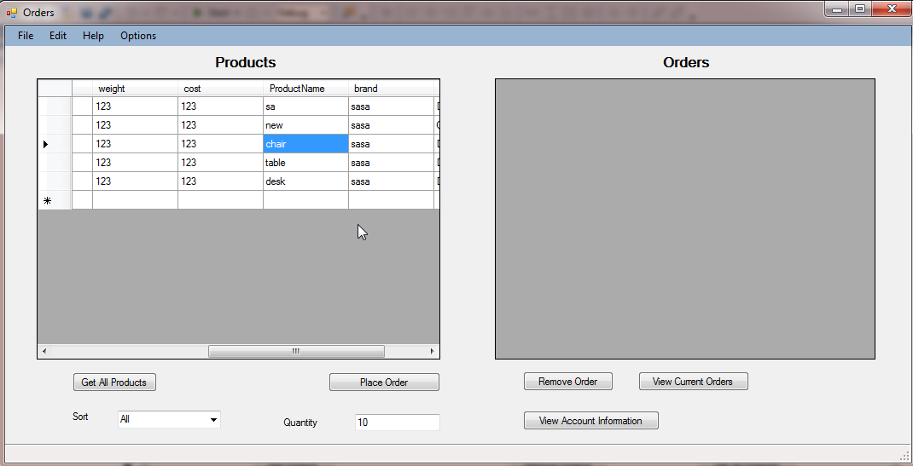

One order of 10 chairs.

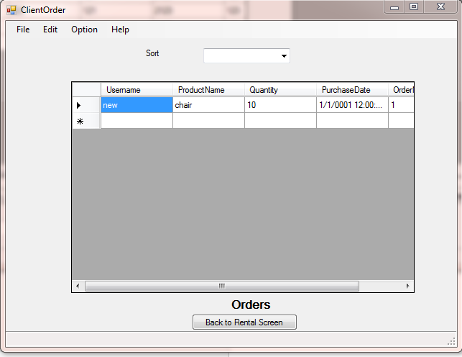

Able to do multiple Orders.

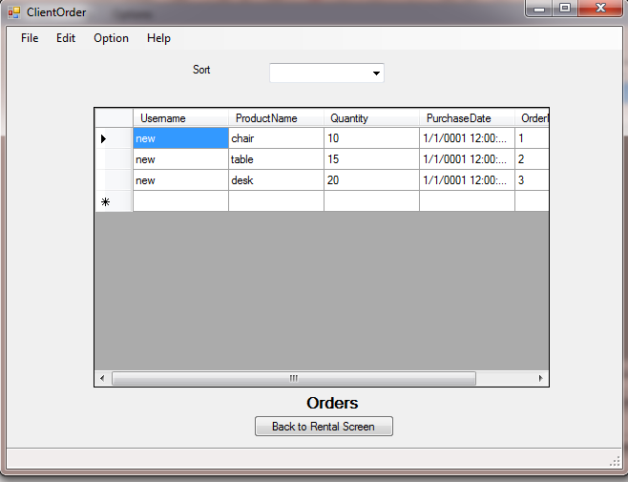

**Register**

**Register with invalid User**

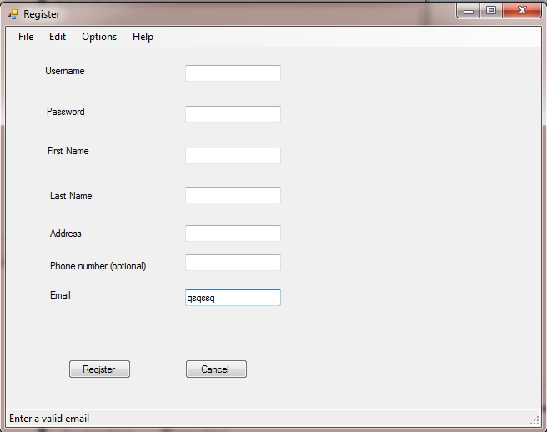

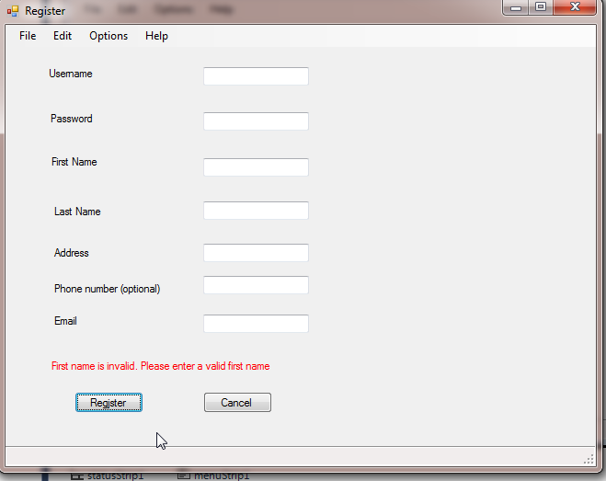

**Register with valid credentials**

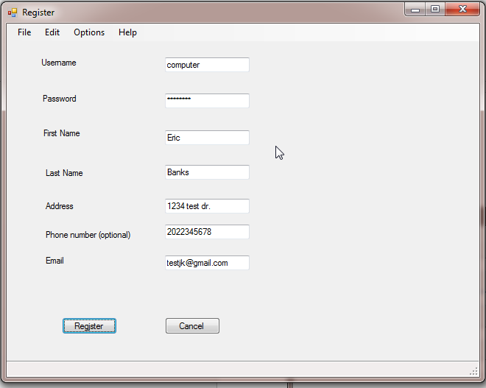

**User is successfully register. Can Login.**

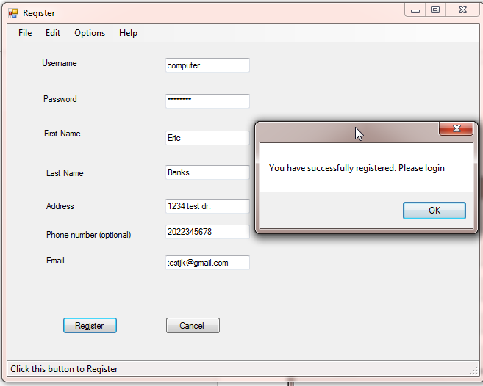

**Admin. Can login as admin user if user is an admin. Admin User Extends User through inheritance.**

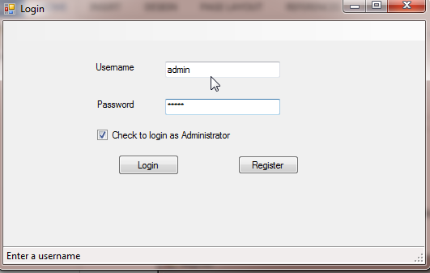

**Able to do various Admin options such as changing customers, users(might be guestuser that are not customers), products, and run SQL in the databse.**

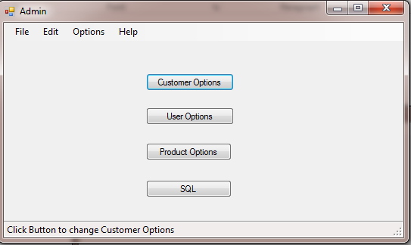

**Admin can retrieve all customers and remove customers**

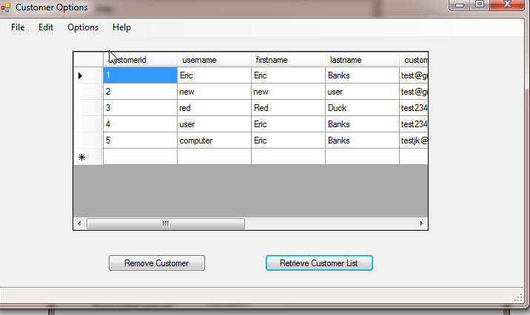

**Admin able to add and remove user**

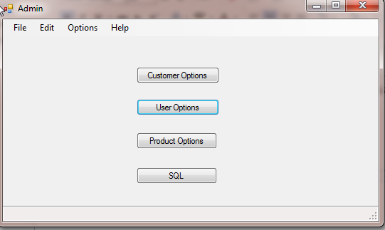

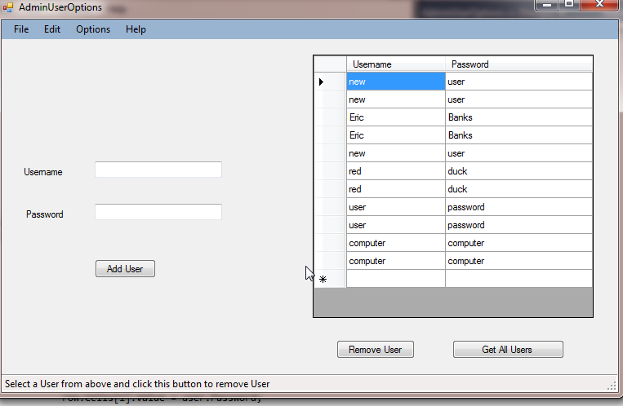

select * from Product;

select * from Customer;

select * from Orders;

